**CURRICULUM VITAE**

Uladzimir Yeudakimovich

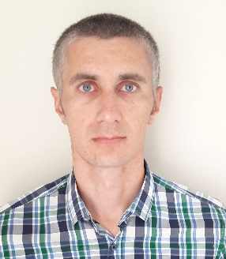

email [uladzimir.yeudakimovich@gmail.com](mailto:uladzimir.yeudakimovich@gmail.com)

site [https://uladzimir-yeudakimovich.ml](https://uladzimir-yeudakimovich.ml/)

phone +375 33 3344201

Personal Profile

Software Engineer with experience of creation single page application using frameworks such as Angular, Angular Material, Bootstrap and various libraries, support application written using AngularJS.

Responsible and highly trustworthy with analytical, problem solving and troubleshooting capability. Results oriented and customer focused, with excellent relationship management skills.

Self-motivated and able to work to own initiative, persistent to work under pressure, flexible with the ability to juggle priorities effectively, ambitious to drive the career forward and willing to learn.

Qualifications / Education

* Harvard University, course Computer Science CS50, 2017
* The Rolling Scopes School: front-end development 2017-2018
* Udemy, Angular 7 course, 2018

Languages

* English: B1/B2 level
* Russian: native speaker

IT Skills

* Angular
* AngularJS
* Angular material
* Vue
* React
* React Native
* Bootstrap
* JavaScript
* REST
* Git
* webpack
* mocha
* SASS and LESS
* HTML5 and CSS3

Employment History

# Software Engineer, lifetech (Turkcell Group), Minsk

(February 2019 – Present)

Achievements and responsibilities:

* Support and improvement of the application on AngularJS ([https://mylifebox.com](https://mylifebox.com/))
* Working with REST API

# Software Engineer, iMlab, Minsk

(December 2018 – February 2019)

Achievements and responsibilities:

* Creating application on Angular 7 and angular material (https://lk.ikassa.by)
* Working with REST API

# Software Engineer, OCS Innovation Company (OCSICO®), Minsk

(September 2018 – December 2018)

Achievements and responsibilities:

* Creating application on Angular 6 and angular material
* Support application on AngularJS
* Working with REST API

Software Engineer, Generalov Group, Minsk

(April 2018 – September 2018)

Achievements and responsibilities:

* Creating application on Angular 4 and Bootstrap 4 (https://www.abamahotelresort.com)
* Working with REST API
* Interaction with back-end

Software Engineer, Freelance Web Development, Minsk

(March 2017 – April 2018)

Achievements and responsibilities:

* Creating adaptive and interactive pages by layout
* Optimization web-pages
* Working with REST API